**Leader Overview**

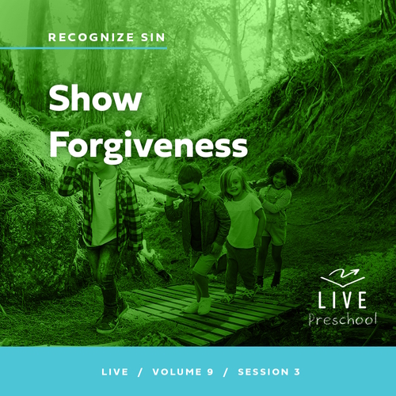

**Volume Overview**

**Recognize Sin**

*The Bible has a lot to say about sin and forgiveness. It acknowledges the deep brokenness of this world and our individual life. It is only by understanding the depth of human sin that we can understand the remarkable work of God’s forgiveness. Because of His forgiveness, we escape the eternal consequence of our sin and can rightly respond to the call to live a holy life. We learn to receive forgiveness, put off sin, and show forgiveness to those who have sinned against us. We learn to pursue holiness in the midst of the world’s brokenness.*

**Session Overview**

**Show Forgiveness**

*In this* **Live** *session, preschoolers will explore the parable Jesus told of a man who owed a lot of money to a king. Surprisingly, the king forgave his large debt. But then the man didn’t forgive someone who owed him money. Kids will discover that God calls us to forgive others, and we can do it with God’s help.*

**Bible Lesson**

The Parable of the Unmerciful Servant

[Matthew 18:21–35](https://ref.ly/logosref/Bible.Mt18.21-35)

**Faith Fact**

I can forgive others.

**Faith Verse**

[2 Corinthians 5:17](https://ref.ly/logosref/Bible.2Co5.17) (NLT)

Anyone who belongs to Christ has become a new person. The old life is gone; a new life has begun!

**Preparing for the Session**

**Leader Preparation Time: 20–25 Minutes**

|  |
| --- |
| ***You Will Need***  ***Preservice Activities***  *• Toys*  *• Dry erase board*  *• Black dry erase marker*  *• Eraser*  *• Cookies*  ***Large Group***  *• Bible*  *• Worship songs (Song suggestions: “Never Be Shaken” by Shout Praises Kids; “King of Me” by Rend Co. Kids; “Never Be the Same” by Fellowship Worship)*  *• For groups not using a phone or tablet only, add:*  *• Projector or TV*  *• Laptop*  *•* ***Faith Fact Sound*** *video (bell ringing)*  *•* ***Faith Fact Slide***  *•* ***Faith Verse Slide***  *•* ***Faith Verse Video***  *•* ***Bible Lesson Video A***  *•* ***Bible Lesson Video B***  ***Small Group***  *•* ***Small Group Activity Page****, one per kid*  *• Pencils or pens, one per kid*  *• Crayons or markers*  *• 9-inch balloon, uninflated*  *• Empty plastic disposable bottle*  *• 1 cup of water*  *• Small clear cups, three*  *• Food coloring, three colors*  *• Flexible straw*  *• Tape*  *• Knife or scissors*  *• Large bowl that sits next to the bottle and below the straw to catch the water that comes out*  *To access session content and videos from a computer, visit:* [***BibleEngagementProject.com/downloads***](https://bibleengagementproject.com/downloads) |
| ***Getting Ready***  ***Preservice Activities***  *• Set out toys and snacks.*  ***Large Group***  *• Download videos and slides if needed.*  *• Select worship song(s) and have them ready to play.*  ***Small Group***  *• Print copies of the* ***Small Group Activity Page****, one per kid.*  *• Pour 1/3 of the water into each cup.*  *• Color the water in each cup with the three different colors of food coloring. Choose colors that will make a muddy color when mixed.*  *• Place a small cut halfway up the bottle and insert the straw into it.*  *• Tape the straw in place, so it won’t fall out.*  *• Optional: Watch the video about the object lesson.* [*https://www.youtube.com/watch?v=SLy7zXo3fQ0*](https://www.youtube.com/watch?v=SLy7zXo3fQ0)  ***First time leading* Live *for Preschool? Check out the*** [**Facilitator Guide**](https://0b769b0ed3569ef9d18b-f88d8272f61086866d50d048b43ef630.ssl.cf2.rackcdn.com/sites/biblengagementproject/Listen_Facilitator_Guide.pdf)**.** |

**Preservice Activities**

*See what’s needed at the beginning of the session.*

**Bible Story Warm-Up**

Have you ever had someone be mean to you?

What kinds of things do people do that hurt others?

How does it make you feel when someone hurts you?

Is it easy or hard to forgive them for what they did?

• *Scribble on the white board for each response.*

I just made a huge mess on this marker board when you told me about the mean things that can hurt us. It was nice and clean before, but now it’s not. If we don’t forgive others when they hurt us, we can be a lot like this board. We get filled up with hurts and unforgiveness. *Unforgiveness* is a big word that means we stay mad at people who have hurt us. Unforgiveness lets what others do keep hurting us on the inside.

What could I do to make it clean again? *(Allow responses.)* God wants us to forgive people who hurt us. Forgiving them is like taking this eraser and wiping away the bad feelings *(wipe the marks off the board)*. God can help us do that with our feelings on the inside. Kind of cool, huh?

In our Bible story, we’ll learn the importance of forgiveness. We’ll find out the best reason to forgive others. Learning from the Bible is one of my favorite things to do, and I love that I get to do that with you today.

**Snack**

**Cookies**

I’ve brought this whole package of cookies with me for snack. Someone gave them to me before I came today. What will you have for snack? *(Allow responses.)* Oh! You want some of my snack! I guess I could do that.

• *Take a few of the cookies and break them in smaller pieces.*

• *Hand a small piece to each kid.*

You can eat your snack now. Did you get enough snack? *(Group response)* Do you think it’s fair that I got this whole package of cookies and only gave you a few pieces? *(Group response)* You’re right. It isn’t fair.

Today, we’ll learn about a man in the Bible who got more than he deserved from the king just like when I got this whole package of cookies. Then, the man turned around and didn’t treat someone else fairly like when I only gave you pieces of cookies. How many of you want to eat a whole cookie? *(Group response)*

• *Hand each kid a whole cookie and let them eat the snack.*

**Free Play**

*Any extra time can be spent playing with toys.*

**Transition**

*A few minutes before service begins have kids make their way to the large group area and sit in their designated areas.*

**Large Group**

**25 Minutes**

*See what’s needed at the beginning of the session.*

**Introduction**

Hi, everyone! What a great day it is when we get to be here together! I love getting to know more about who God has created you to be. I also love exploring God’s Word, the Bible, *(hold up the Bible)* with you so we can discover more about who God is.

Today, we’ll hear a story Jesus told about forgiveness. Forgiveness is when we let go of bad feelings we have toward someone who hurt us. Is it easy to forgive someone when they have hurt us? *(Group response)* It’s never very easy, and sometimes it can be very hard.

In the story Jesus told, a man owed a king a huge amount of money, but the king forgave his debt and said he didn’t need to pay it. Forgiveness seemed to be easy for the king to do. Guess what happened when that same man was asked to forgive a debt someone else owed him. Wait! You’ll have to listen to our Bible story to hear what choice he made. First, let’s talk more about forgiveness.

**Faith Fact**

Jesus forgives our sins, and He wants to help us forgive others when they treat us unfairly. That’s our Faith Fact today. **I can forgive others.**

• *Show the* ***Faith Fact Slide.***

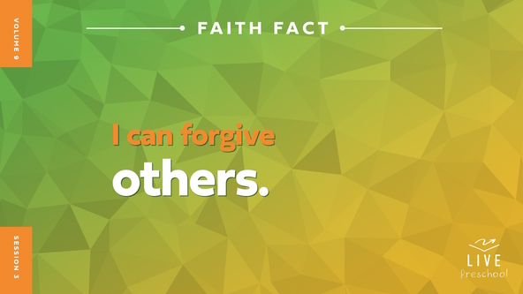

Let’s say our Faith Fact together. **I can forgive others**. Let’s whisper it this time. **I can forgive others**. Now, let’s yell it out for everyone to hear. **I can forgive others**. Well done!

**Bible Time**

Let’s check in with Lizzy and hear more about the story Jesus told His friends. I can’t wait to find out what happened.

• *Play* ***Bible Lesson Video A****.*

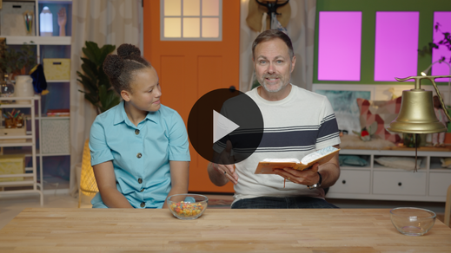

I’m glad Grandpa gave us a little time to think! Let’s worship now. Then, I’ll ask you what you think will happen next in our Bible story.

**Worship**

Jesus was such an amazing storyteller! When I hear how Jesus talked to people, I’m reminded of how much He loves everyone. Let’s give God our best praise and worship and tell God how much we love Him.

**Praise**

Are you glad Jesus forgives us? Reach your fingers to the sky. *(Group response)*

Who’s ready to forgive others? Give the friend next to you a high five. *(Group response)*

Who wants to tell God how great He is? Spin around. *(Group response)*

**Sing**

It’s great to praise God like that! Let’s warm up our singing voices to worship God. La-la-la-la! *(Group response)*

• *Lead the kids in singing one or two songs. See song suggestions at the beginning of the session.*

**Prayer**

What a beautiful sound it is to hear your voices worshipping God. Let’s talk to Him.

|  |
| --- |
| *Dear God, we love You because You first loved us. We may never understand how much You love us, but we thank You for it. We also thank You for the forgiveness You give us, and we ask You to help us forgive others. Amen.* |

**Bible Time cont’d**

Grandpa and Lizzy will be back soon! Let’s put on our thinking cap *(demonstrate)*. What do you think happened next in our story? Did the man who had his big debt forgiven by the king decide to forgive the person who owed him money? *(Point to the “thumbs-up” graphic.)* Or did he not forgive the man’s debt so that he still owed a lot of money? *(Point to the “thumbs-down” graphic.)*

• *Have kids do the following actions from the screen.*

If you think the first man forgave the second man’s debt, then give a thumbs-up. If you think the first man didn’t forgive the second man’s debt, then give a thumbs-down. Let’s find out if you’re right! Here are Lizzy and Grandpa.

• *Play* ***Bible Lesson Video B.***

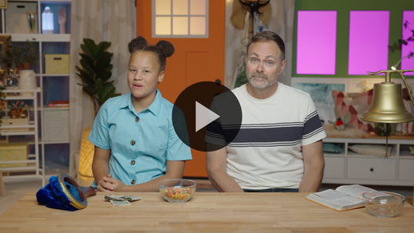

**Response Time**

*Play a worship song quietly.*

Wow, that was an important story Jesus told! Let’s respond to the truth we’ve heard today. Sometimes it’s really hard to forgive someone, but God is always ready to help us. Can you wrap your arms around yourself in a hug? That’s how close Jesus wants to be with us as He helps us forgive someone. Look down and close your eyes tightly.

If there is someone who has hurt you and you know you need to ask God to help you forgive them, I want you to raise your hand. *(Pause for response.)* God will help you forgive. Let’s pray and ask Him to do that together.

• *Have the kids repeat phrases of the prayer after you. Then follow up with these kids later as needed.*

|  |
| --- |
| *Dear God, You are so good to me. You love me. You forgive me. I want to forgive others who need it. Sometimes it’s hard, so I’m grateful You help me. I love You. Amen.* |

There’s one more important thing I want you to remember about forgiveness. Forgiving what someone has done to us is between us and God. Sometimes what a person has done means we wouldn’t be safe around them anymore. If that has ever happened to you and you don’t feel safe with someone, it’s important to talk to an adult you trust and feel safe with. If they don’t listen, tell another adult that you trust. Just because you forgive someone doesn’t mean that God says you have to let that person keep hurting you. Make sure you tell someone what has happened.

**Faith Verse**

One of the best things we can do for our heart is memorize Bible verses. Let’s practice our Faith Verse and do the actions together.

[2 Corinthians 5:17](https://ref.ly/logosref/Bible.2Co5.17) (NLT)

Anyone who belongs to Christ has become a new person. The old life is gone; a new life has begun!

• *Show the* ***Faith Verse Video****.*

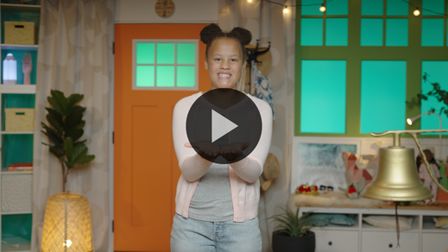

**2 Corinthians** *(hands at waist, spread apart, palms up and out)*

**5:** *(hands together like a clap)*

**17** *(hands opened to “book”)*

**Anyone who** *(point to other people)*

**belongs to Christ** *(do sign language for Jesus, middle finger to opposite palm, with each hand)*

**has become a new person.** *(spin around)*

**The old life is gone;** *(crouch low to ground)*

**a new life has begun!** *(jump with arms and feet spread wide)*

**Closing**

Wave your hand at me if you’ve enjoyed exploring God’s Word today. *(Wave your hand at kids.)* I’m waving my hand because I have, too! I love worshipping God and learning Bible verses with you. Let’s all remember to ask God to help us forgive others.

• *Play the* ***Faith Fact Sound*** *video (bell ringing).*

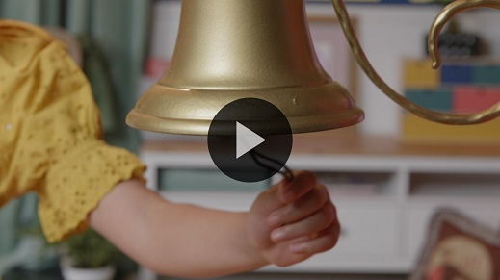

That sounds means it’s time to practice our Faith Fact one more time. **I can forgive others**.

• *Show the* ***Faith Fact Slide.***



Let’s say our Faith Fact and point to ourself when we say *I*. **I can forgive others**. Now, point to a friend as we say *others*. **I can forgive others.**

**Dismissal to Small Groups**

Wonderful! It’s time for something very special. Can anyone guess what we’re doing now? *(Allow responses.)* Yes, it’s time to go to our small groups.

• *Dismiss the kids by groups.*

|  |
| --- |
| ***Leader Tip:*** *This can be done by assigning color teams or by age groups. Note that some young preschoolers may not know their age. Using a colored sticker, jersey, or wristband will help separate the kids and help identify their small groups.* |

**Small Group**

**25 Minutes**

*See supplies and prep instructions at beginning of session or in each activity below.*

|  |
| --- |
| ***Leader Tip****: Small groups can alternate to each circle, or all groups can do each activity at the same time. If you choose to alternate, you will need at least one leader per circle.* |

**Circle 1**

**Group Connection**

**New Stuff**

|  |
| --- |
| *No prep needed for this activity.* |

Have you ever gotten something brand-new? *(Group response)* What did you get? *(Allow responses.)* Wow! Those are some pretty awesome things! I love getting things like new shoes for instance. I wear shoes every day. How about you? *(Group response)* Sometimes they get dirty, and I wash them off. There are other times when my shoes get worn out and get a hole in them. Even if I washed them, my shoes wouldn’t be as good as new.

Have you ever needed something new because you wore it out? *(Group response)* What if a friend broke your toy? Would you rather they try to glue it together or get you a new one? *(Group response)*

When we believe in God and ask Him to forgive our sins, He does. He doesn’t just want to fix our life. He wants to make it brand-new. That’s what our Faith Verse teaches us. Let’s say it together, but let’s try saying it in some crazy ways. Who’s ready? *(Group response)*

• *Lead kids through saying the Faith Verse and doing the actions.*

[2 Corinthians 5:17](https://ref.ly/logosref/Bible.2Co5.17) (NLT)

Anyone who belongs to Christ has become a new person. The old life is gone; a new life has begun!

**2 Corinthians** *(hands at waist, spread apart, palms up and out)*

**5:** *(hands together like a clap)*

**17** *(hands opened to “book”)*

**Anyone who** *(point to other people)*

**belongs to Christ** *(do sign language for Jesus, middle finger to opposite palm, with each hand)*

**has become a new person.** *(spin around)*

**The old life is gone;** *(crouch low to ground)*

**a new life has begun!** *(jump with arms and feet spread wide)*

• *Let kids choose different voices/styles to say the verse: slow motion, very fast, cowboy, robot, etc.*

That was pretty amazing! The more you say the verse, the better you’ll know it. That makes me so excited!

**Circle 2**

**Activity Page Time**

**Forgiveness Journal**

|  |
| --- |
| ***You Will Need***  *•* ***Small Group Activity Page****, one per kid*  *• Pencils or pens, one per kid*  *• Crayons or markers*  ***Getting Ready***  *• Print copies of the* ***Small Group Activity Page****, one per kid.* |

Today, we learned that we should forgive others. In our Bible story, we heard about a servant who was forgiven a huge debt by the king. Then, the man didn’t do the same for someone who owed him a lot less money. He got in big trouble for doing that. God is like the king in the story. He wants us to forgive others because He has forgiven us.

• *Hand out a copy of the* ***Small Group Activity Page****, a pencil, and crayons to each kid.*

I want you to think about a friend, brother, or sister who has hurt you. Maybe you have forgiven them for what they did already or maybe not. Draw a picture of that person and what they did to hurt you.

• *Allow time for kids to complete their drawing. Ask them if they’d like to share what they drew with you.*

• *During the activity, interrupt and practice the Faith Fact:* **I can forgive others.**

• *Play the* ***Faith Fact Sound*** *video****.*** *Review the Faith Fact even if you can’t play the sound.*



Sometimes when we forgive other people, we may not tell them. Instead, it may be a prayer that we pray to God, and a decision that we make in our heart. If you haven’t forgiven this person yet, you might want to pray with someone about it today.

Remember, just because someone else is unkind to us doesn’t mean we can be unkind back. When we choose to forgive someone, we should show them kindness. It might help them change the way they act around us. Even if they never change the way they are, we still need to forgive them. That doesn’t mean we have to spend time with them. It just means we don’t let their actions affect us anymore.

**Circle 3**

**Feet-to-Floor Game Time**

**Tag and You’re Not It**

|  |
| --- |
| *No prep is needed for this activity.* |

Does anyone here want to play a game? *(Group response)* Perfect! This game is called Tag and You’re Not It. Now, what that means is one of you will be “It” and tag everyone, but someone else gets to be the “Untagger.”

If you get tagged, you must freeze and be as still as a statue. You can easily get back into the game. You just need the “Untagger” to unfreeze you by giving you a high five and saying, “I can.” Then, you’ll say, “Forgive others.” When you say that, you’ll be free to move around again. Anytime you hear me say, “Forgive,” we’ll all freeze and say our Faith Fact together. Then, I’ll pick two new people to be “It” and the “Untagger.” Let’s play!

• *Play the game until you run out of time.*

That was awesome! You are not only fast runners but also quick forgivers. It was so cool to hear you say the Faith Fact as you were getting unfrozen. I’m praying that you will learn to forgive others as quickly outside of our group as you were to help unfreeze your friends.

**Circle 4**

**Hands-On Learning**

**Jesus Forgives Object Lesson**

|  |
| --- |
| ***You Will Need***  *• 9-inch balloon, uninflated*  *• Empty plastic disposable bottle*  *• 1 cup of water*  *• Small clear cups, three*  *• Food coloring, three colors*  *• Flexible straw*  *• Tape*  *• Knife or scissors*  *• Large bowl that sits next to the bottle and below the straw to catch the water that comes out*  ***Getting Ready***  *• Pour 1/3 of the water into each cup.*  *• Color the water in each cup with the three different colors of food coloring. Choose colors that will make a muddy color when mixed.*  *• Place a small cut halfway up the bottle and insert the straw into it.*  *• Tape the straw in place, so it won’t fall out.*  *• Optional: Watch the video about the object lesson.* [*https://www.youtube.com/watch?v=SLy7zXo3fQ0*](https://www.youtube.com/watch?v=SLy7zXo3fQ0) |

Sometimes it can be hard to forgive other people. If we aren’t careful, we can carry those bad feelings around with us. Let me show you what that’s like. Our life can be like this bottle. *(Hold up the bottle with the straw in it.)* Right now, it’s empty and nice and clear. That’s what we should feel like on the inside. When others hurt our feelings or treat us badly, it can cause us to carry around hurt, anger, and sadness*.*

• *Pour a cup of colored water into the empty water bottle. Continue adding the remaining two cups as you talk.*

• *Mix the colors by swirling the different colors of water together.*

With all those hurts inside of us, we may no longer feel clean inside. Those things they did to us are stuck inside. That’s what unforgiveness can feel like. When this happens, who can help us? *(Group response)* We can ask Jesus to help us forgive others. Asking Jesus to help us is like blowing up this big balloon.

• *Blow up the balloon but do not tie it. Pinch the opening closed with your fingers.*

• *Make sure the bowl is placed under the straw.*

As we pray about forgiveness, we give our hurts to Jesus. Let me show you what it’s like when He helps us forgive others. First, I’ll put the balloon’s opening over the top of the bottle.

• *The pressure from the balloon pushing the air into the bottle will make the water push up through the straw and out of the bottle.*

Look! The hurts are gone. When we ask Jesus to forgive us, it makes us clean on the inside. Jesus wants you to forgive when someone hurts you. You can ask Jesus to help you show forgiveness to others. Remember, we can forgive others because He has forgiven us!

**Dismissal**

• *Play the* ***Faith Fact Sound*** *video (bell ringing).*



• *Show the* ***Faith Fact Slide.***



Wow! What a great day of learning we’ve had together! I love anytime that we get to praise, pray, and learn more about God’s Word together. Can you help me say our Faith Fact one more time? **I can forgive others**. Awesome job! See you next time!

• *Send home the* ***Small Group******Activity Page*** *with each kid.*

• *Remind parents that there are* ***Family Devotions*** *available on the app to do with their kid.*

• *Tell everyone the date and time for the next session.*